**Lab 5 Documentation**

**Moving distance at different PWM**

|  |  |
| --- | --- |
| **PWM** | **Velocity** |
| 70 | 0.1 inch/s |
| 180 | 0.5 inch/s |
| 255 | 2.5 inch/s |

**Notice:** The moving distance might vary due to the friction of the board and the screw. The level of lubrication of the gear will also cause the screw to move further or shorter.

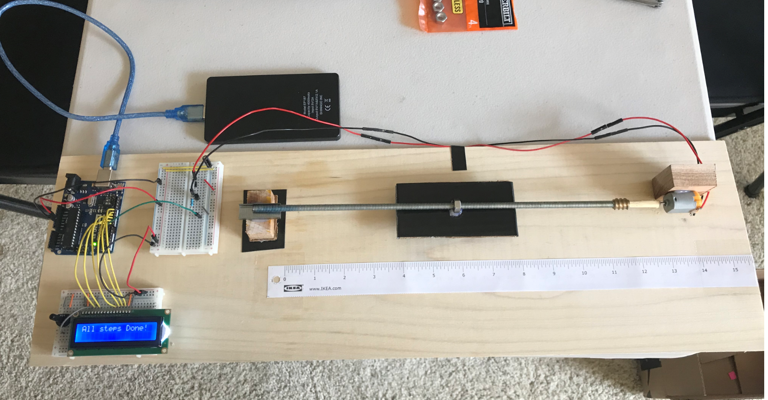

**The linear motion control setup**

Things I’ve acquired for this lab: USB power supply, lead screw, follower nut, wood plate, wood stick, glue gun, electric tape, two bread boards, paper ruler.

The most challenging part was to get everything I needed for this lab. I’ve visited Home Depot, IKEA, and RadioShack to get essential components to build this linear motion control system. Still though, the wood board from Home Depot is not perfectly flat, curved in the middle, which cause the motion in the middle of the screw very hard to control (friction too high). I’ve also separated the LCD display board with Motor control board because a DC motor is an inductive electronic component that will interfere the signal sending to LCD display, that may cause LCD displays random characters. Other than that, Arduino coding and motion calibration process were not hard at all.

The error of the moving distance could be greatly reduced if the system is built on a smooth metal rod with a DC motor that has greater torque.

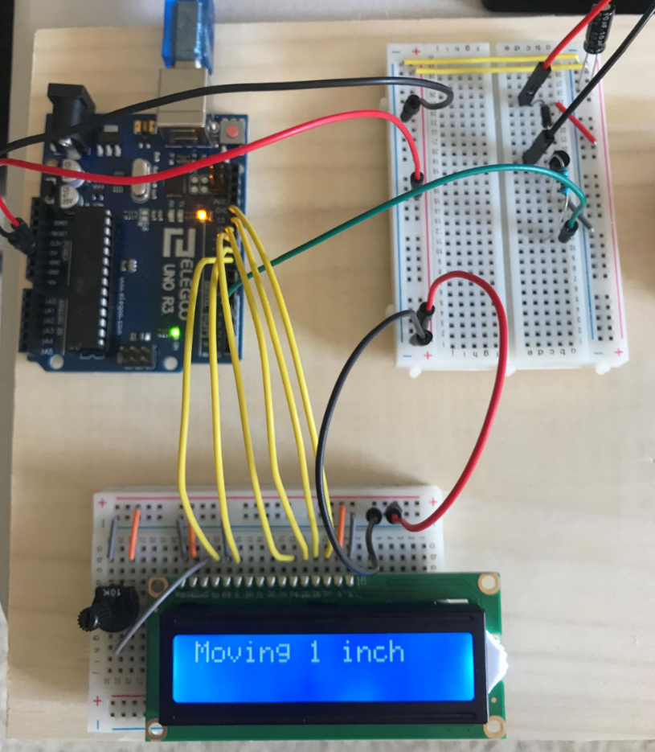

**Moving 1 inch**

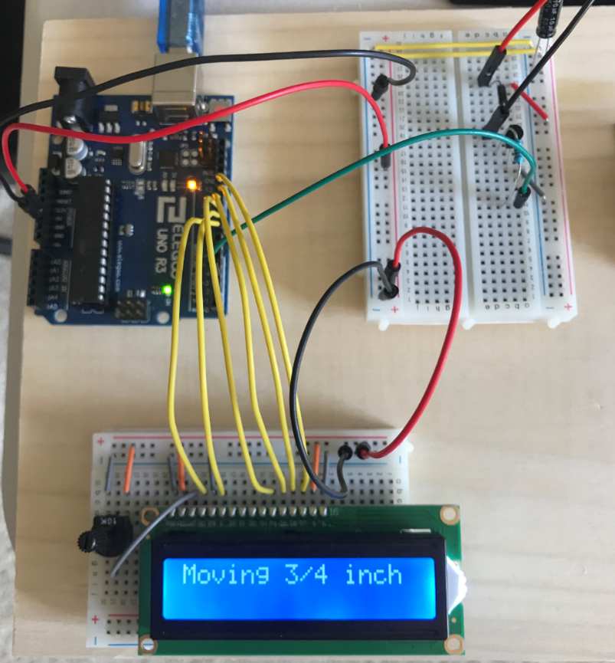

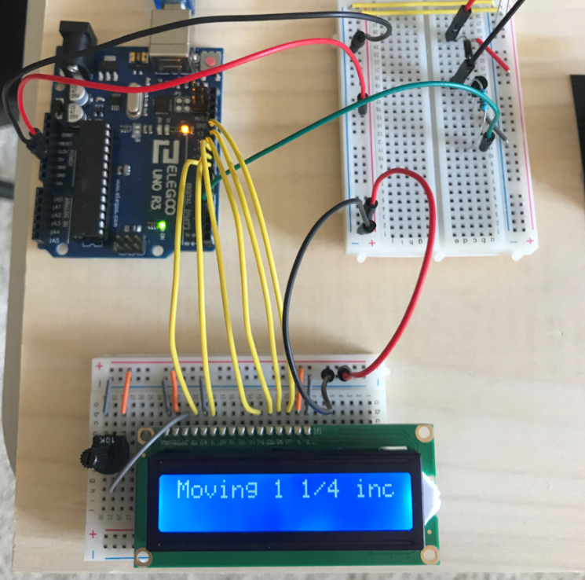**Moving 0.75 inches**

**Moving 1.25 inches**

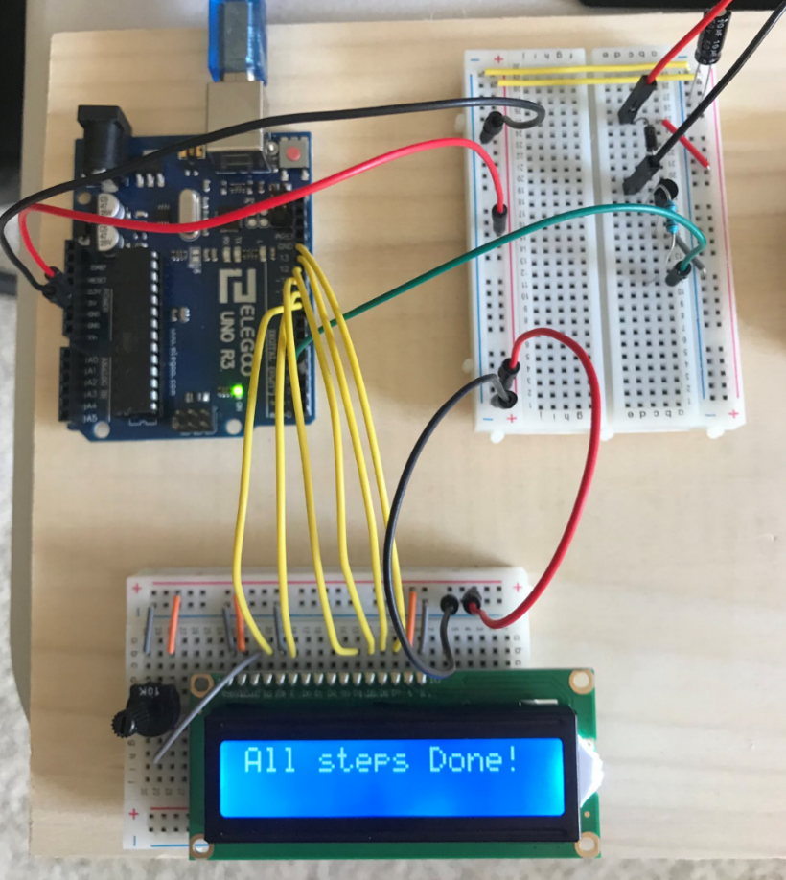**Print “All Steps Done!” once the motion is completed**

**Code**

/*  lab5 Zhibo Wang

Linear Motion Control

 */

#include <LiquidCrystal.h>

LiquidCrystal lcd(8, 9, 10, 11, 12, 13);

const int motorPin = 3;

const int maxPWM = 255;

const int adjPWM = 170;

void setup()

{

    Serial.begin(9600);

    lcd.begin(16, 2);

    pinMode(motorPin, OUTPUT);

    delay(1000);

    motionControl();

}

void loop()

{

}

void motionControl()

{

    lcd.print("Moving 1 inch");

    analogWrite(motorPin, maxPWM); // torque initializer

    delay(50);

    analogWrite(motorPin, adjPWM);

    delay(1500);

    analogWrite(motorPin, 0);

    delay(3000);

    lcd.clear();

    lcd.print("Moving 3/4 inch");

    analogWrite(motorPin, maxPWM); // torque initializer

    delay(50);

    analogWrite(motorPin, adjPWM);

    delay(1100);

    analogWrite(motorPin, 0);

    delay(3000);

    lcd.clear();

    lcd.print("Moving 1 1/4 inch");

    analogWrite(motorPin, maxPWM); // torque initializer

    delay(50);

    analogWrite(motorPin, adjPWM);

    delay(1850);

    analogWrite(motorPin, 0);

    lcd.clear();

    lcd.print("All steps Done!");

}